SAM AI Technologies
Your dream your passion
Data Analyst Internship
Task Submission Report
Overview
This report summarizes the work completed for the Data Analyst internship at SAM AI Technologies. The dataset used across all tasks is a cleaned restaurant dataset (cleaned_dataset.csv) containing 9,551 restaurant records across 141 cities, with fields including city, price range, ratings, votes, cuisines, and online delivery availability.
Task 1: City-wise Restaurant Analysis
Objective
- Identify the cities with the highest number of restaurants.
- Compare the average ratings of restaurants across different cities.
- Visualize the top 10 cities by restaurant count using a bar chart
Approach
Using pandas, restaurant counts were grouped by city with value_counts(), and the top 10 cities were plotted using seaborn. For the average rating comparison, an additional filter was applied to only include cities with at least 5 restaurants, since a raw average across all 141 cities was heavily skewed by cities with only 1–2 entries.
Key Findings
Top city by restaurant count | New Delhi — 5,473 restaurants
2nd and 3rd | Gurgaon (1,118), Noida (1,080)
Highest avg. rating (min. 5 restaurants) | London — 4.535
Other high performers | Orlando (4.475), Bangalore (4.375), Hyderabad, Chennai
Terminal output and Charts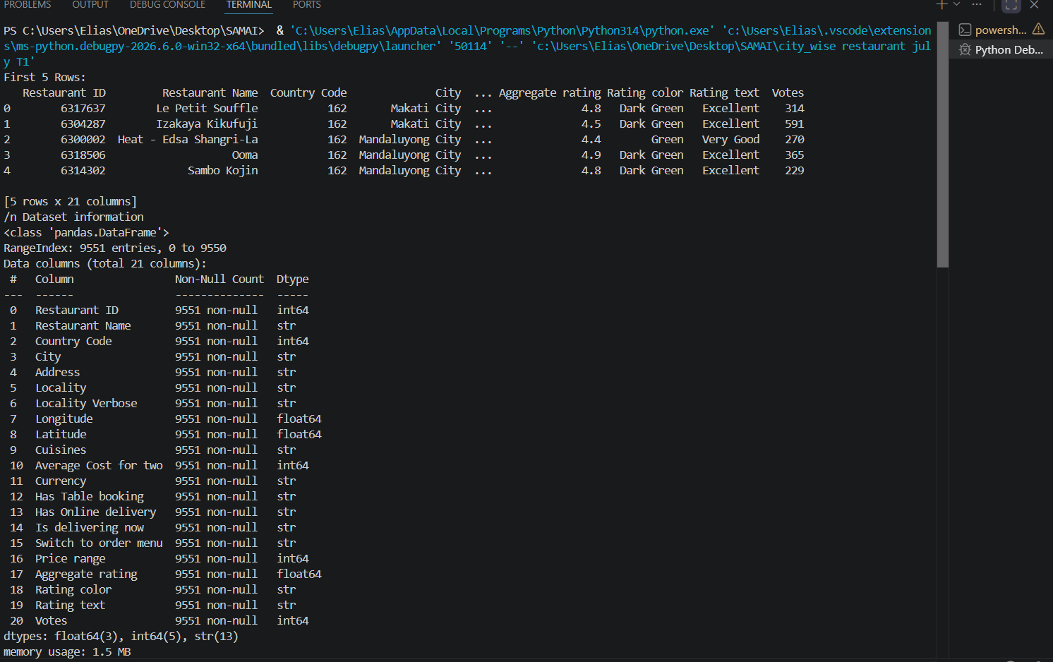
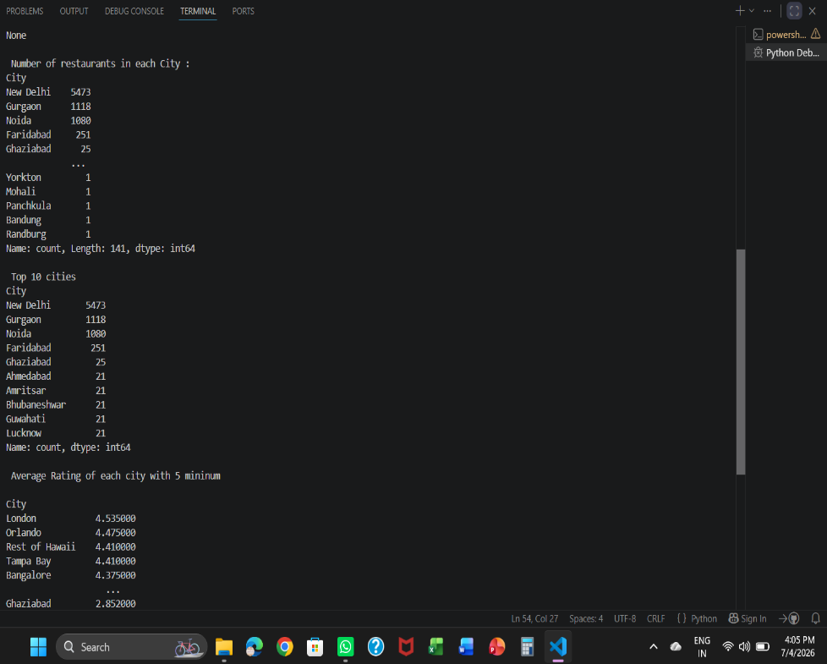
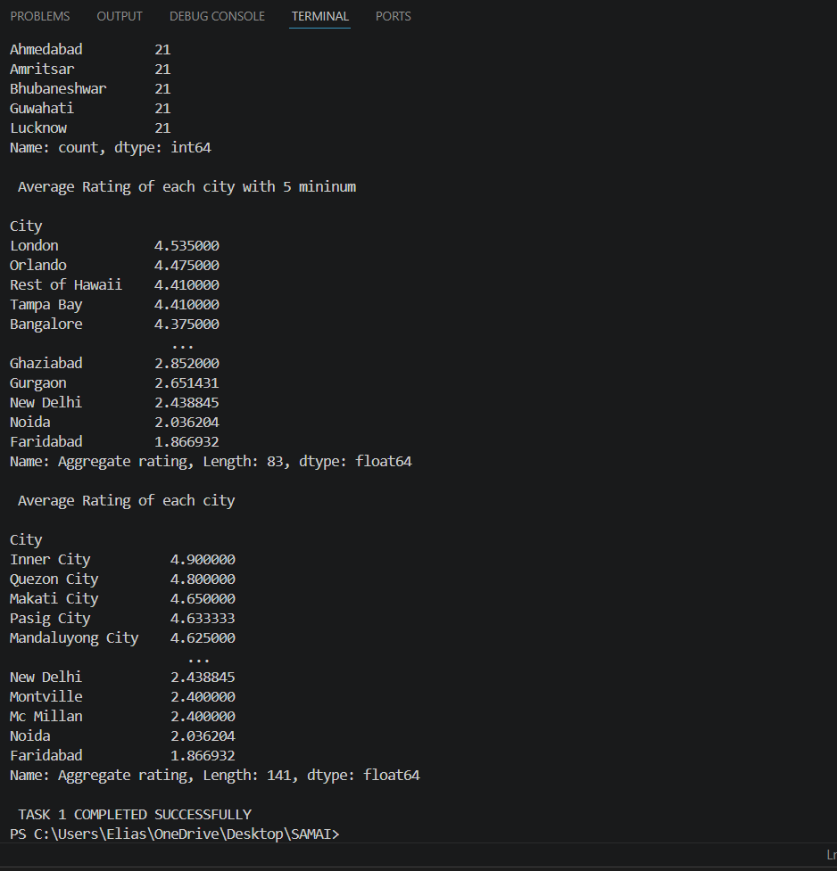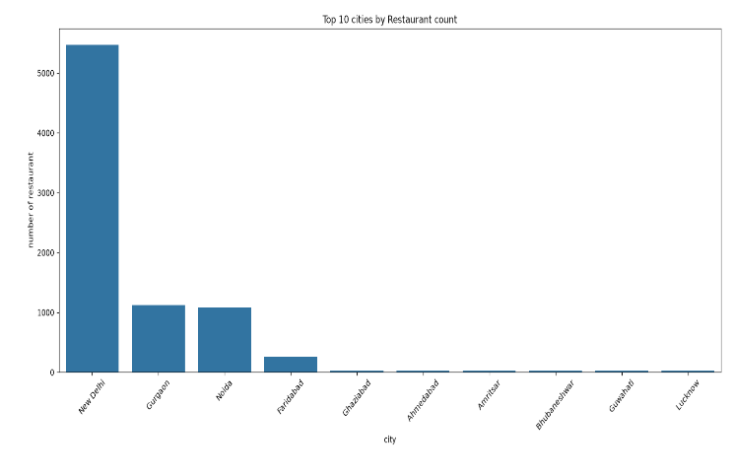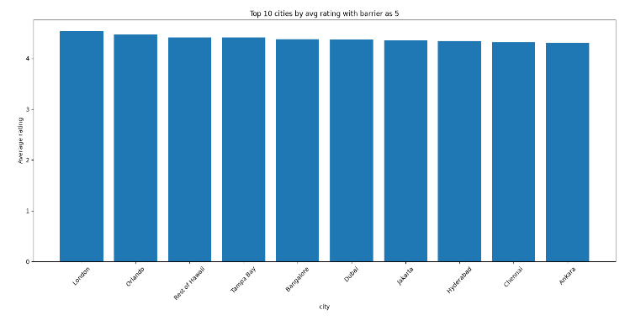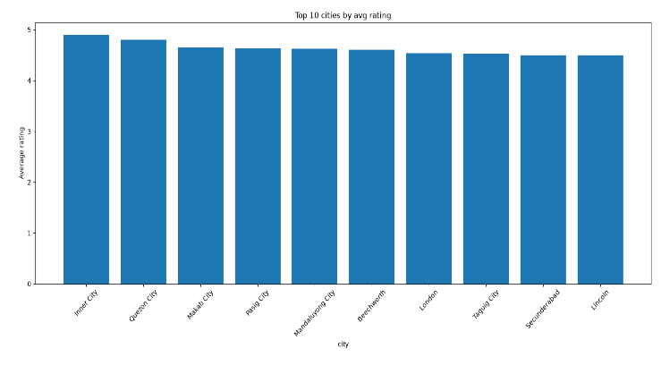
Task 2: Online Delivery Analysis
Objective
- Analyze how many restaurants offer online delivery.
- Compare average ratings of restaurants with and without online delivery.
- Create charts showing the percentage of restaurants providing online delivery.
Approach
The 'Has Online delivery' column was grouped to get counts and percentages, and average ratings were compared between the two groups using groupby(). Results were visualized with a bar chart (counts), a pie chart (percentage split), and a bar chart (rating comparison).
Key Findings
Restaurants without online delivery | 7,100 (74.3%)
Restaurants with online delivery | 2,451 (25.7%)
Avg. rating — without delivery | 2.47
Avg. rating — with delivery | 3.25
Restaurants offering online delivery have a noticeably higher average rating than those that do not, despite being the smaller group.
Terminal Output and charts
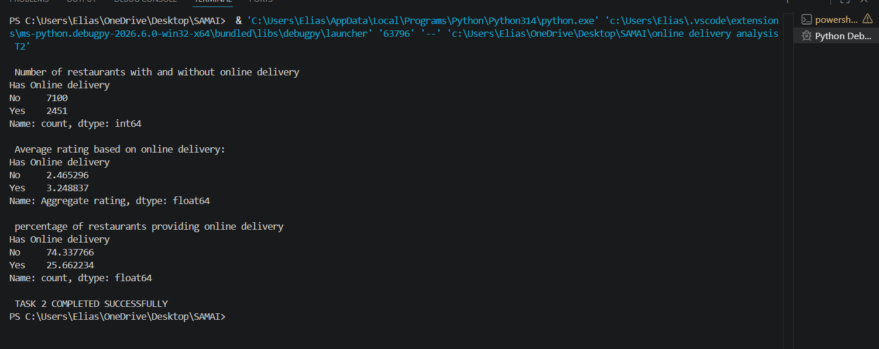
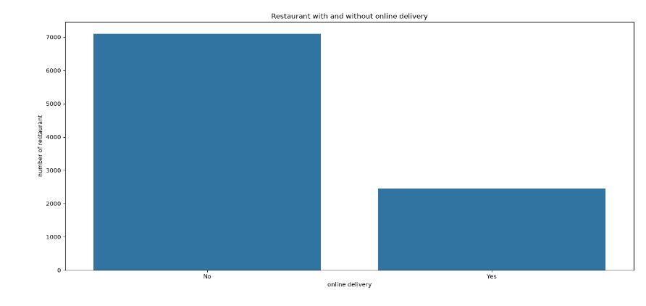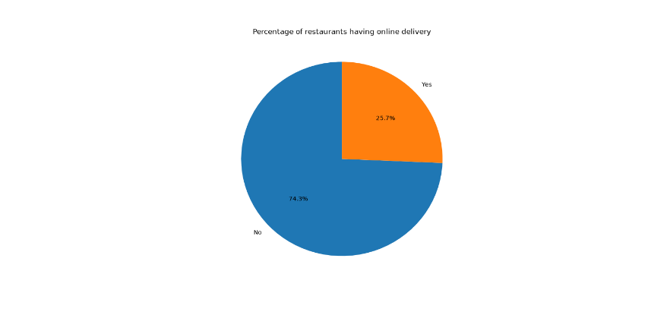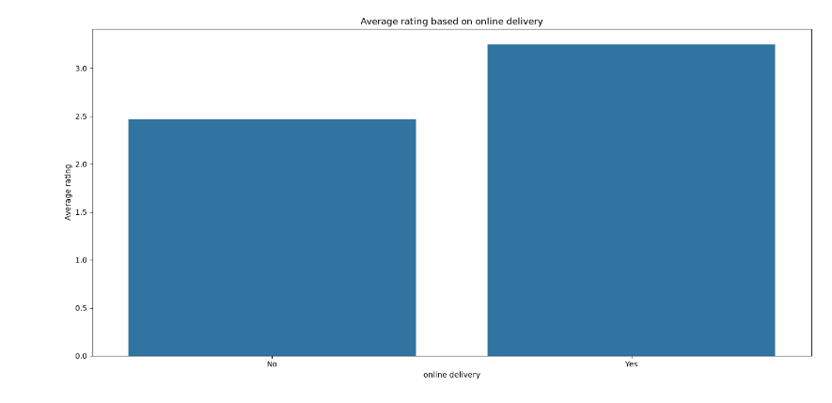
Task 3: Price Range Analysis
Objective
- Analyze the distribution of restaurants across different price ranges.
- Identify which price range has the highest average rating.
- Visualize results using bar charts and pie charts.
Approach
Restaurant counts were grouped by the 'Price range' column (1 = lowest, 4 = highest) and visualized with a bar chart and a pie chart. Average rating was calculated per price range using groupby(), and the price range with the highest rating was identified using idxmax().
Key Findings
Price range 1 (lowest) | 4,444 restaurants — avg. rating 2.00
Price range 2 | 3,113 restaurants — avg. rating 2.94
Price range 3 | 1,408 restaurants — avg. rating 3.68
Price range 4 (highest) | 586 restaurants — avg. rating 3.82
Highest-rated price range | Price range 4 — Average rating 3.82
There is a clear positive trend: as price range increases, average rating increases, even though restaurant volume decreases.
Terminal Output
